**Table of Contents**

Introduction.............................................................................................................pg. 2

Research..................................................................................................................pg. 3

Goals.......................................................................................................................pg. 4

Objectives...............................................................................................................pg. 5

Program Activities..................................................................................................pg. 5

Priority Publics Involved........................................................................................pg. 6

Recommended Communication Channels.............................................................pg. 6

Message Themes....................................................................................................pg. 7

Calendar/ Timetable of Events...............................................................................pg. 8

Budget....................................................................................................................pg. 8

Day One Event Details.........................................................................................pg. 10

Day Two Event Details.........................................................................................pg. 11

Evaluation.............................................................................................................pg. 12

Appendices...........................................................................................................pg. 13

References............................................................................................................pg. 19

**Introduction**

CommuniCon is an event that was created in 2019 by the Department of Communication. The event showcases opportunities offered by the department, creates connections, recognizes student achievements, and promotes academic growth. For the 2025 CommuniCon, our team proposes a Hollywood-themed event that displays the chances for stardom within the Department of Communication.

CommuniCon: Day One will be open to the entirety of the Augusta University student body. The event will exhibit different aspects of the department using informational booths, which will include tables for clubs within the Department of Communication. The Media Production Club, Esports program, and the Bellringer team will be in attendance alongside other communication initiatives. Students will also have the opportunity to learn about gaining professional experience and preparedness through internships and certificates. The event will take place in front of the Grover C. Maxwell Performing Arts Theatre. The location is central on the Summerville campus which will allow visibility for students not yet affiliated with the Department of Communication.

CommuniCon: Day Two will be an event exclusive to communication students. This day will focus on recognizing students for their achievements, appreciating the faculty, and having alumni highlight their professional experience. This portion will take place at the JSAC Coffeehouse. There will be catered Mexican food, Hollywood-themed trivia, a raffle of donated prizes, and a slideshow presenting examples of student work for attendees.

CommuniCon will be an exciting experience not only for students and faculty of the department, but also any students curious about broadening their academic career. This years' experience focuses on shining a spotlight on the Department of Communication in a way that will encourage new and upcoming stars.

**Research:**

Our CommuniCon: Day One feedback survey was sent out to all of the students in the communication department and posted on multiple public channels, which resulted in 90 responses. The majority of survey respondents were freshmen. Additionally, the highest demographic of respondents were students whose majors did not affiliate with the department. This is advantageous for our planning, as our overall objective is to showcase what a career in communication can offer. With non-major students showing interest, this gives us the opportunity to show them the less familiar, more enticing aspects of communication.

The majority of voters elected “Hollywood: Lights, Camera, CommuniCon” as the theme for this year’s event. The most requested activities included a photobooth, crafts, and trivia. We also had several write-ins for live music. We will be offering these exact activities as per the survey results. Regarding entertainment, we also plan to offer an inflatable attraction, raffle prizes, and an authentic red-carpet experience.

For food options there was a tie in the survey between Mexican food (tacos, burritos, etc.) and cookout food (burgers, hotdogs, etc.). Our team decided to offer cookout food for Day One, as having an outdoor event in the heat calls for the classic ease of American finger food. On Day Two we will cater Mexican food for communication students and faculty. (**Appendix A** for more detailed graphs and additional survey information)

There are various ways to approach increasing attendance and creating an overall successful event. In a study conducted by educational psychologist Jacqueline Goldman, Ph.D., it was established that positive emotions in academia led to higher rates of engagement. If we are able to replicate an environment that produces positive emotions based on the atmosphere, then there will be a greater likelihood of engagement from the Augusta University student population. This can potentially be achieved by utilizing music, activities, and opportunities that will be offered at CommuniCon.

Similarly, adolescent psychologist Michael J. Bradley, Ph.D., reiterates the importance of a welcoming and positive atmosphere. This research pertains to college students’ social involvement and information retention. It is shown in Bradley’s research that environment plays a part in the probability of increasing both retention and involvement. CommuniCon will have a better prospect of intriguing both new and returning students if the atmosphere is inviting.

Communication professor Brent D. Ruben, Ph.D., and Public Policy professor Tricia Nolfi addressed the ways that student organizations can be improved. Their writing brings forth aspects of communication theory that are conducive to planning our event. In particular, how the success of the event relates to the preparedness and organization that precedes the event itself. This article explains that student organizations are improved when they practice comprehensive planning skills where the goals and objectives are clearly stated. Using this logic, we can contribute to the greater success and improvement of CommuniCon by ensuring that our strategies are identified and followed. By taking these steps, we largely improve our chances of meeting our set goals.

**Goals for CommuniCon 2025:**

1. Increase awareness to non-communication majors and educate them about the strengths of the Department of Communication.
2. All attendees will be both entertained and informed through booths and stations.
3. Provide equal opportunities for all students to interact and connect with the faculty in hopes of building a new network.
4. Create a fun, educating, and sociable environment for those who come and participate at CommuniCon.

**Objectives:**

1. At least one-fourth of our total attendees at CommuniCon: Day One will be non-communication majors.
2. Students will tour and participate in at least five informative booths that display assets of the department.
3. Collect 8-10 donations for raffle prizes
4. CommuniCon-related content on social media should show at least a five percent increase in engagement compared to previous posts.
5. All participating students on Day One take a satisfaction survey where we aim to receive at least a 65 percent approval rating. Survey information will be sent out using student emails from the raffle.

**Program Activities:**

The following activities are proposed for CommuniCon: Day One:

* A cookout will take place with burgers, hotdogs, and snacks.
* Students will check informational tables off their “VIP Pass.”
  + Tables will include the Bell Ringer, Esports program, GetUp Productions, Sport Squad, and information about videography, media, and internships.
* Photo opportunities
  + The Instagram cutout features Augusta University and the Department of Communication.
* Yard games and outdoor activities
  + Ring toss, cornhole, inflatable, etc.

The following activities are proposed for CommuniCon: Day Two:

* Mexican food will be catered.
* Dr. Taylor Walker will host Hollywood-themed trivia.
* Augusta University alumni guest speakers
  + Two graduates from the communication department will speak about their professional experiences.
* Oscar-themed faculty awards
  + Voted on by students pursuing majors in communication.
* Raffle prizes

**Priority Publics Involved:**

The target audiences for CommuniCon: Day One are non-major students and students whose paths are undetermined. Day One is additionally intended to showcase the benefits and versatility of taking on a communication-related minor or certificate. CommuniCon: Day Two is exclusive to the established members of the communication department. The main focus of Day Two is to foster and create relationships amongst students and staff, and offer students in the department a glimpse of what their futures could look like.

**Recommended Communication Channels:**

The following methods of communication are proposed to advertise CommuniCon 2025:

* Email: The CommuniCon general feedback survey was sent to all students and faculty in the Department of Communication.
* Word of Mouth: We requested various professors to promote the event to their students regardless of their affiliation to the department.
* Flyers: We plan to physically post flyers throughout the Health Sciences and Summerville Campuses.
* Social media: The Department of Commnication’s official Instagram will share our flyers as well as promote the event. Additionally, the CommuniCon general feedback survey was posted on the University’s Snapchat story.

**Message Themes:**

This year’s message theme is focused on how we could relate our Hollywood concept to the core aspects of communication. Ensuring a glamorous environment while highlighting important factors of communication is at the top of our priority list. While designing flyers to promote the event, we aimed to depict the essence of each day of CommuniCon. Day One is focused on getting students to network with members of the department, so we implemented aspects of Hollywood on our Day One flyer. We chose to allude to Hollywood with a bold red-carpet design and classic elements of pop culture. Paired with the golden background, we expect the flyer to stand out and shine for CommuniCon 2025.

CommuniCon: Day Two is inspired by award ceremonies that celebrate pop culture such as the Academy Awards, the Grammys, and the Met Gala. We will celebrate students' achievements, give recognition to professors, and provide students with first-hand information about the professional world. The flyer displays a trophy in the spotlight to reference the hard work that deserves acknowledgement.

Our goal is to bridge the gap between theory and occupational opportunities utilizing our Hollywood theme. We are featuring alumni who are professionals within the field of communication to provide insight on success. Moreover, the thematic facets of award shows are centered on giving credit where it is due, and we plan to celebrate the Department of Communication by doing just that.

**Timeline:**

|  |  |
| --- | --- |
| **Timeline** | |
| February 28 | Reach out to Alumni for CommuniCon Day Two panel |
| March 5 | Create social media posts to promote CommuniCon (Instagram and Facebook) |
| March 14 | Create press release and email drafts to send out |
| March 21 | Finalize faculty and students running tables on Day One |
| March 28 | Finalize Guest Speakers |
| April 4 | Check in on donations amount |
| April 14 | Regroup after spring break and create ten-day execution plan |
| April 16 | Prepping materials for CommuniCon |
| April 18 | Continuing assembling materials for CommuniCon |
| April 21 | Final Preparations for CommuniCon |
| April 23 | CommuniCon Day One |
| April 24 | CommuniCon Day Two |
| April 25 | Alumni Brunch |

**Budget:**

SGA Reimbursement Budget

|  |  |  |
| --- | --- | --- |
| **Item** | **Quantity** | **Price** |
| Great Value burger buns | 25 | $37 |
| Great Value hotdog buns | 19 | $28 |
| 8 ct Morningstar veggie burger | 8 | $64 |
| 64 oz Great Value ketchup | 3 | $9 |
| 20 oz Great Value mustard | 2 | $3 |
| 20 oz Best Food squeeze mayo | 2 | $13 |
| 24 ct Great Value American cheese | 10 | $25 |
| 32 oz Great Value burger dill pickle chips | 2 | $5 |
| 24 ct Dr. Pepper | 1 | $12 |
| 24 ct Sprite | 1 | $13 |
| 24 ct Diet Coke | 1 | $13 |
| 24 ct Great Value water bottles | 2 | $7 |
| 16 lb OG Kingsford Charcoal | 3 | $33 |
| 32 oz Great Value popping corn | 2 | $7 |
| 16 oz Marketside shredded lettuce | 3 | $13 |
| 42 ct Frito Lay family fun mix | 5 | $100 |
| 300 ct Great Value paper plates | 1 | $15 |
| 10 ct Oscar Meyer wieners | 2 | $6 |
| 36 ct Freezepops | 8 | $25 |
| 12 ct Great Value frozen burger patties | 2 | $30 |
| 2 ct Mainstay aluminum pans | 4 | $9 |
| Gold star stickers | 3 | $6 |
| 1 gal Great Value canola oil | 1 | $10 |
| **TOTAL** |  | $483  **$522 (tax included)** |

COMM Department Budget

|  |  |  |
| --- | --- | --- |
| **Item** | **Quantity** | **Price** |
| Ikia’s family grilling services | N/A | $150 |
| Balloons from Amazon | 1 | $15 |
| Theme party decorations from Amazon | 1 | $20 |
| Gold plastic cups from Amazon | 1 | $20 |
| Centerpieces for day 2 from Amazon | 1 | $15 |
| VIP door curtain from Amazon | 1 | $15 |
| Popcorn bags from Amazon | 1 | $13 |
| 100 event t-shirts | 1 | $506 |
| **TOTAL** |  | $754  **$815 (tax included)** |

**Day One Event Details:**

Day One of our event will be held in front of Maxwell Theater and the surrounding area. As part of the experience in Day One, Augusta University students will walk across the “red carpet”. This experience involves the welcome table and the food/check in table. Once the event begins, students will sign in with their full name and school email so that food reimbursements are guaranteed. Students must earn a VIP pass in order to gain access to food. There are internship booths for students to interact with volunteers representing the organization. The purpose of these internship tables is to help students explore communication-related internships, as well as learn how different aspects of the communication field work together. Some of these tables include public relations, media, The Bell Ringer, Esports, podcasting, and videography. The food on the menu for Day One is burgers and hot dogs, and the table is run by PR students at Augusta University as well as catering organizations.

|  |
| --- |
| CommuniCon Activities: Day One |
| Red Carpet Experience |
| Organizations and Information Tables |
| Photo Opportunities |
| Cookout Food |

**Day Two Event Details:**

Day Two will be held in the JSAC Coffeehouse where the screens will display a compilation of student work. This presentation will be shown while guests grab refreshments and mingle. Then, a game of trivia hosted by Dr. Taylor Walker will begin which will test the attendees’ knowledge of Hollywood and communication topics. Following this game, two alums will discuss their experiences moving on from college and entering the professional field. Next, an Academy Awards-style ceremony will be held, honoring the faculty of the Department of Communication. The event will conclude with the announcement of raffle prizes.

|  |
| --- |
| CommuniCon Activities: Day Two |
| Mexican Food |
| Trivia |
| Alumni Guest Speakers |
| Academy Awards for Recognition |
| Raffle |

**Evaluation:**

Sign-In table

* Tracks the number of people attending “CommuniCon: Day One.” Our target is 300-350 guests.
* Tracks the number of people attending “CommuniCon: Day Two”. Our target is 65-70 guests.

Satisfaction Survey

* Send a Google Forms survey directly to students and faculty that attended CommuniCon. Augusta University emails are acquired during events through a QR code.

VIP Passes

* VIP Passes are lanyards that are distributed during CommuniCon: Day One to attendees upon signing in. Engagement with booths will be tracked by gold star stickers. Once guests reach their goal of interacting with at least five booths, the VIP pass will act as a ticket for food. The lanyards given out will be recollected during the event which allows us to track booth engagement.

**Appendix A:**

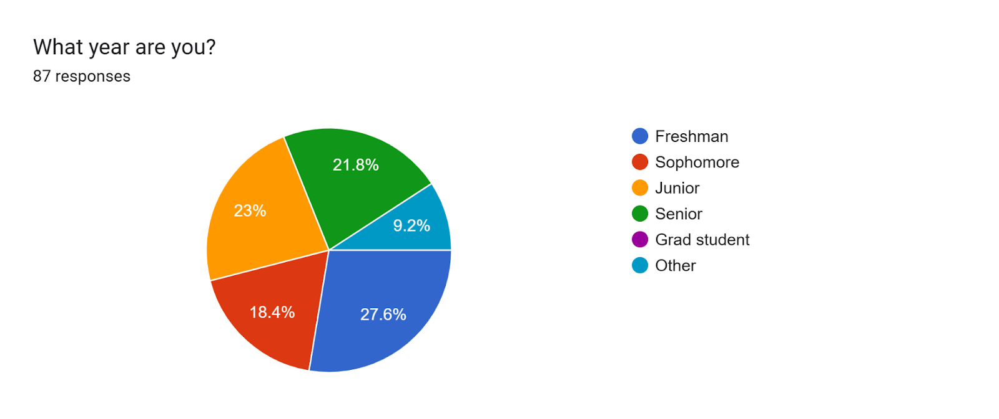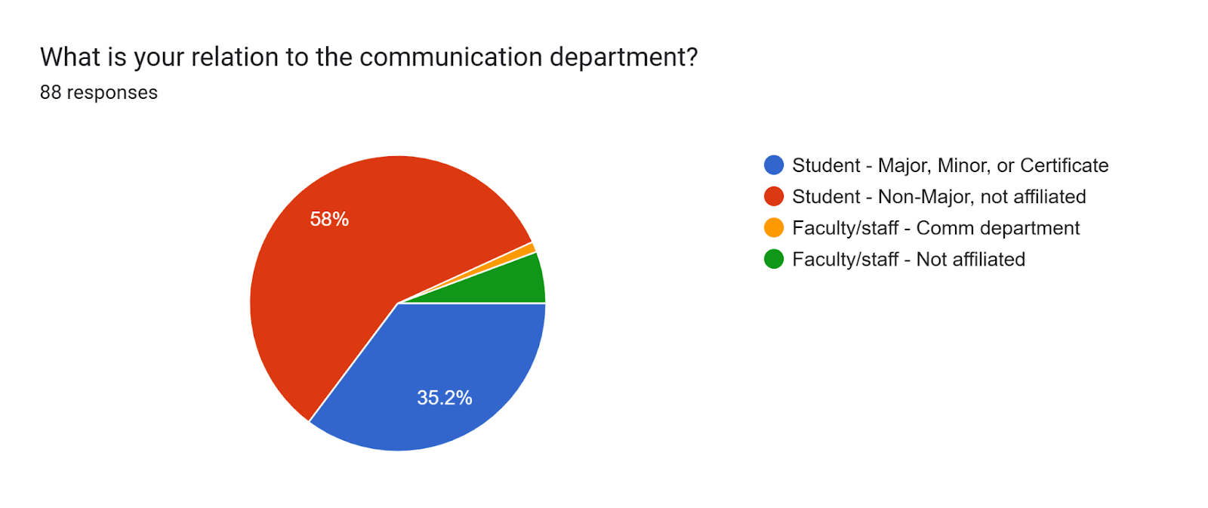

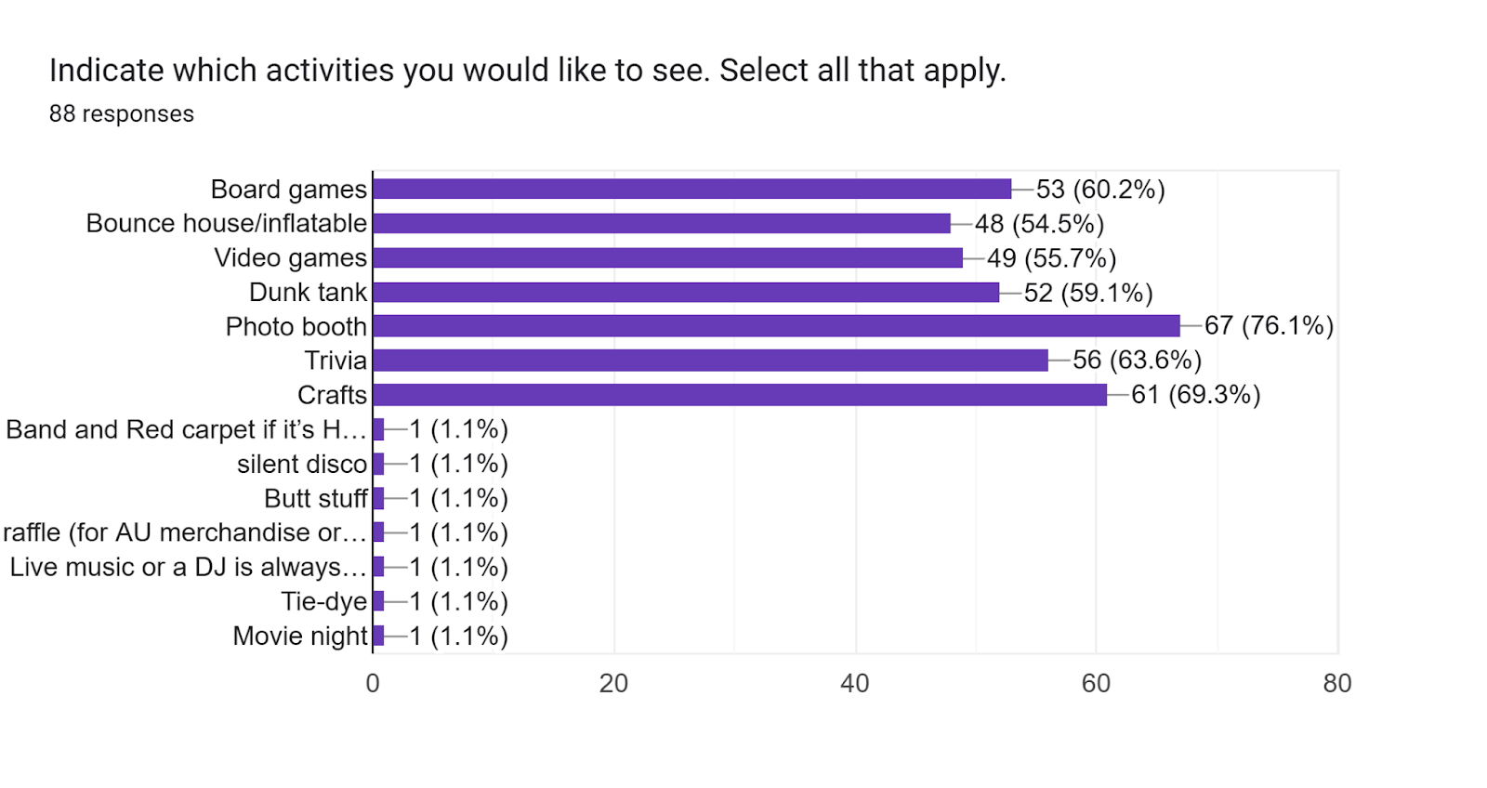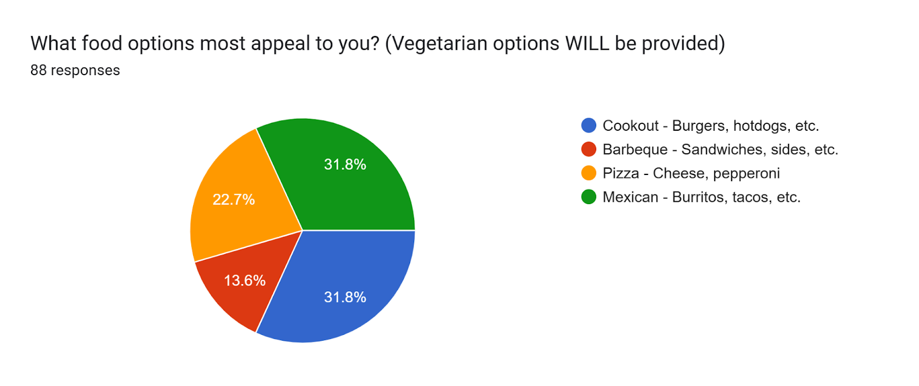

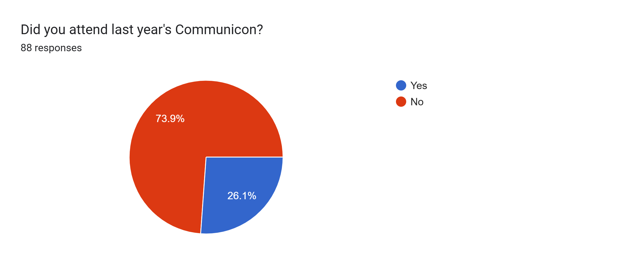

**Appendix B:**

T-shirt Design: Front T-shirt Design: Back

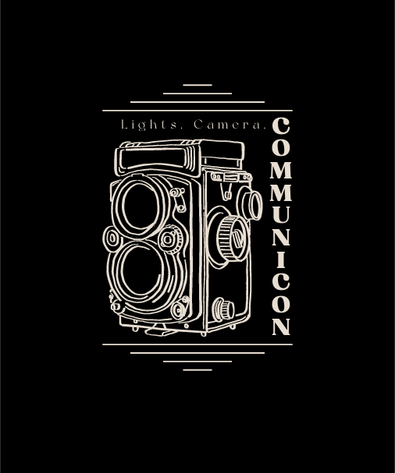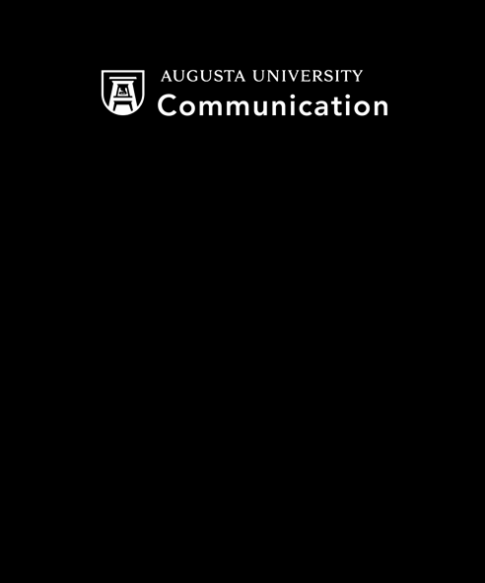

The t-shirt designs will be printed through Blue Ribbon. They have agreed to give us 100 shirts for the price of 50. In addition to this, we will include the logos of businesses who have donated to the event on the back of the t-shirt.

**Appendix C:**

Day One Poster

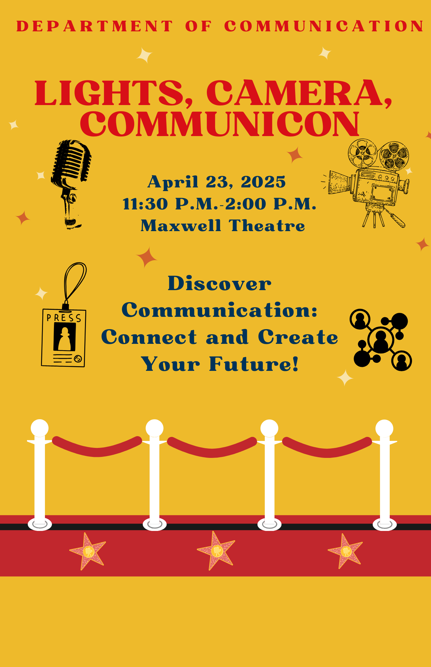

**Appendix D:**

Day 2 Poster

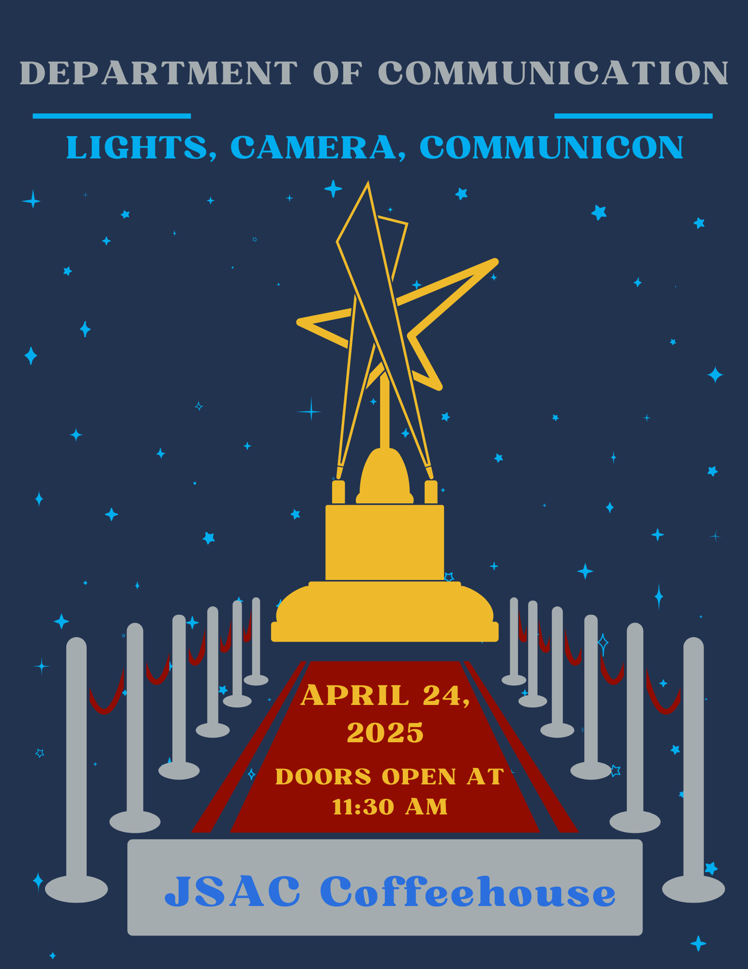

**Appendix E:**

|  |  |
| --- | --- |
| DONATIONS | |
| Texas Roadhouse | 2 gift baskets |
| Fatman’s Café | $25 gift card |
| Swank | $25 gift card |
| Lanier’s | 150 hot dogs |
| Augusta Press | $250 |
| Augusta and Co. | 1 gift basket |
| Escape Outdoors | $25 gift card |
| 7 Brew | 3 $25 gift cards |

**References:**

Bradley, M., Brian, M., McChesney, J., & West, S. (2023). Considerations to Improve College Student Involvement and Retention. *Kentucky SHAPE JOURNAL*, *61*(1), 44–50.

Goldman, J., Cavazos, J., Heddy, B. C., & Pugh, K. J. (2024). Emotions, values, and engagement: Understanding motivation of first-generation college students. *Scholarship of Teaching and Learning in Psychology*, *10*(1), 1–15.

Nolfi, T., & Ruben, B. D. (2010). *Assessing and improving student organizations: a guide for students / Tricia Nolfi and Brent D. Ruben*. Stylus Pub.